SWIGGY (Integration)

How to Integrate Online Third-Party Aggregators with Petpooja
Important Note (Swiggy):To disconnect the Swiggy or Cloud Kitchen integration, you must send an email to support@petpooja.com from your registered email ID, clearly mentioning the reason for the disintegration.
Important Note:
To increase the preparation time in Swiggy, you need to contact the Swiggy Support Team.
Important Note (Swiggy):
Open items with a price of ₹0 are not considered by Swiggy. Please ensure that all open items have a valid price for successful menu sync.

Path : billing.petpooja.com >> Explore products >> integration >> Swiggy.

outletwise_link : https://billing.petpooja.com/market/swiggy_details/
Steps to reach Swiggy :
Step 1 : Billing.petpooja.com in Steps to reach Swiggy : Open your browser and go to billing.petpooja.com.
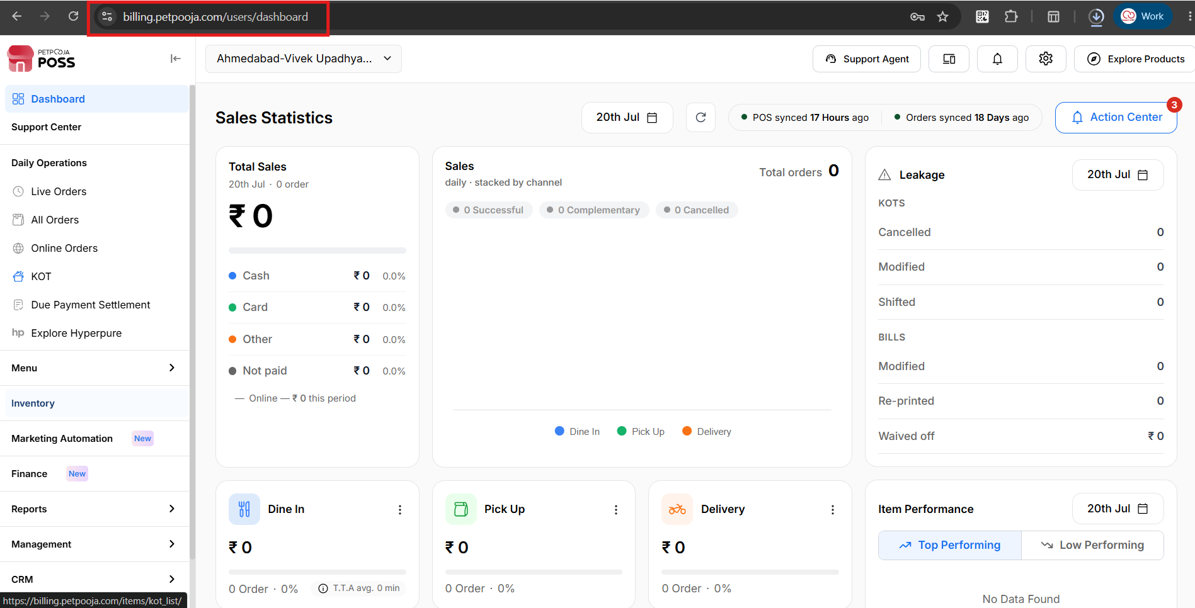
{Image Name: PetPooja Dashboard,
Description: The highlighted URL indicates that this is the billing.petpooja.com.Here is an image of step 1 Billing.petpooja.com in Steps to reach Swiggy}
Step 2 : Marketplace in Steps to reach Swiggy : Click on the Marketplace section from the dashboard.
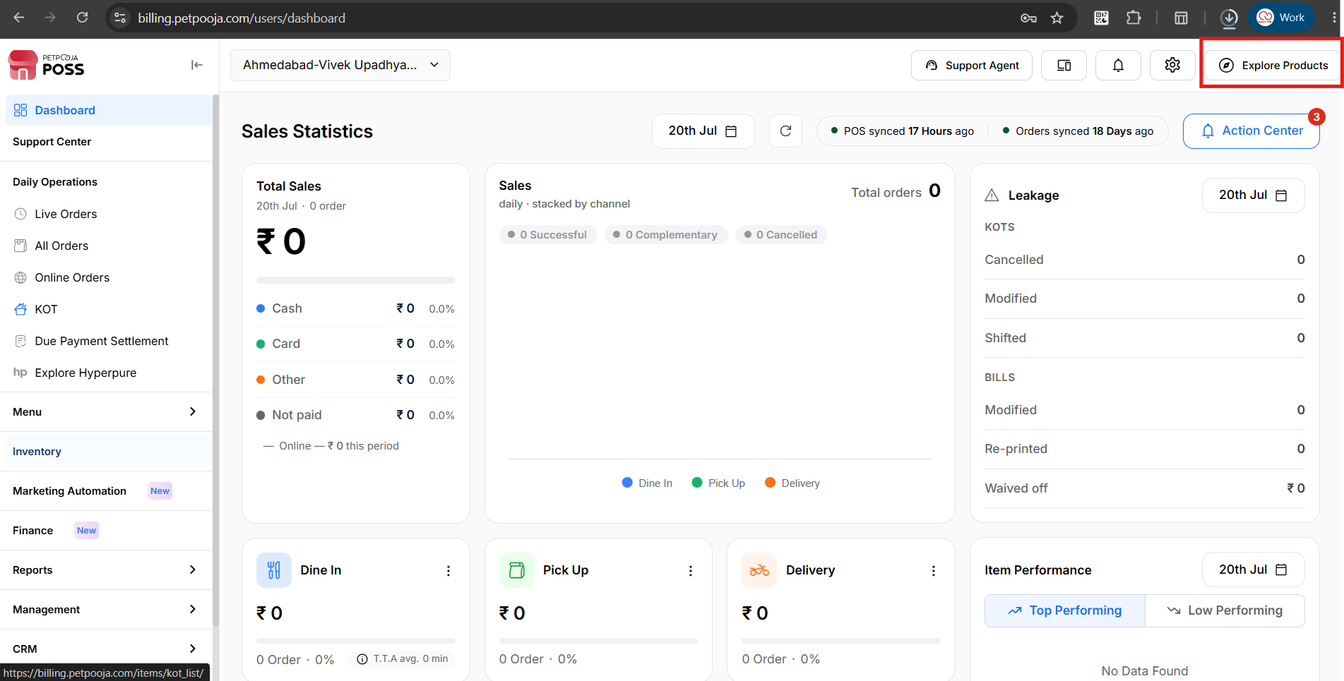
{Image Name: PetPooja Marketplace,
Description :Here is an image shows of In the top right corner, the "Marketplace" button is prominently highlighted in red.Here is an image of step 2 Marketplace in Steps to reach Swiggy}
Step 3 : Integration in Steps to reach Swiggy : Inside the Marketplace section, click on Integration.
Step 4 : Swiggy in Steps to reach Swiggy : Inside Integration, click on Swiggy.
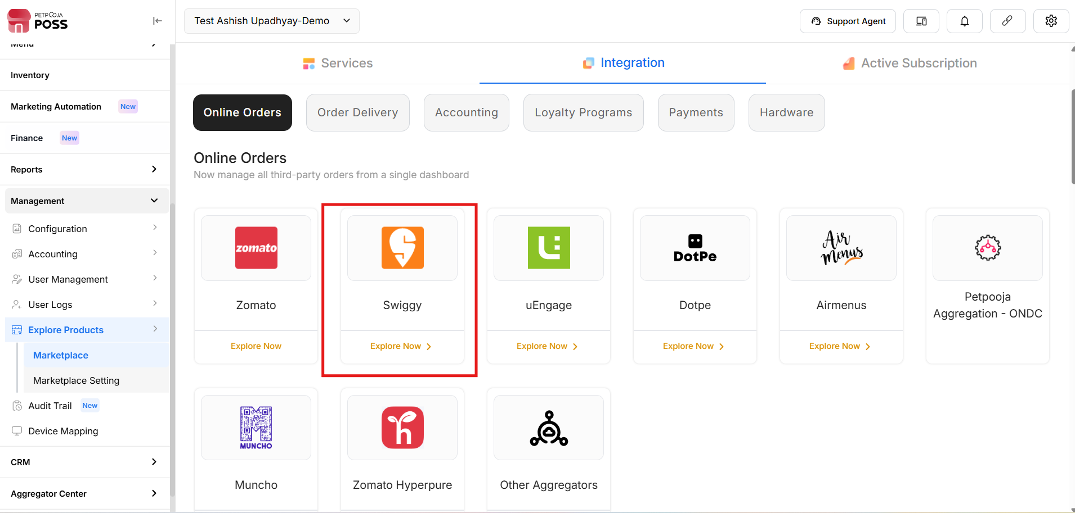
{Image Name : Petpooja Swiggy,
Description : Here is an image showing Swiggy highlighted in the Red Box.Here is an image of step 3 Integration and step 4 Swiggy in Steps to reach Swiggy}
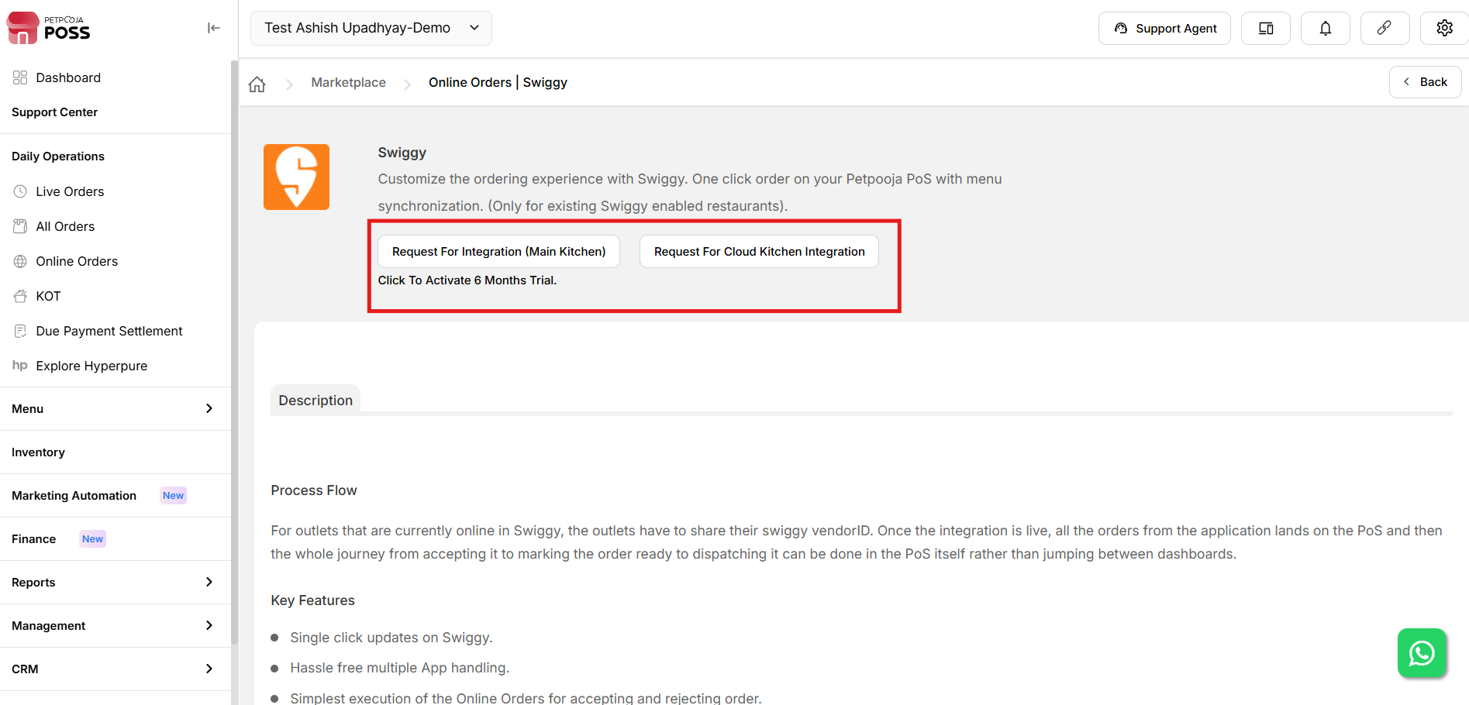
{Image Name: PetPooja Swiggy Integration,
Description: Here is an image showing integration Option to select}

Which Option Should You Choose? (SWIGGY) :

outletwise_link : https://billing.petpooja.com/market/swiggy_details/
- If this is your first integration with Petpooja →Select "Request for Integration (Main Kitchen)"
- If you already have one integration and need a second one →Select "Request for Cloud Kitchen Integration"
(SWIGGY) Note: Kindly allow 2 to 3 working days for the integration process to be fully implemented after you have submitted this form.

How to Fill the Swiggy Integration Form in Petpooja (SWIGGY) :
outletwise_link : https://billing.petpooja.com/market/swiggy_details/
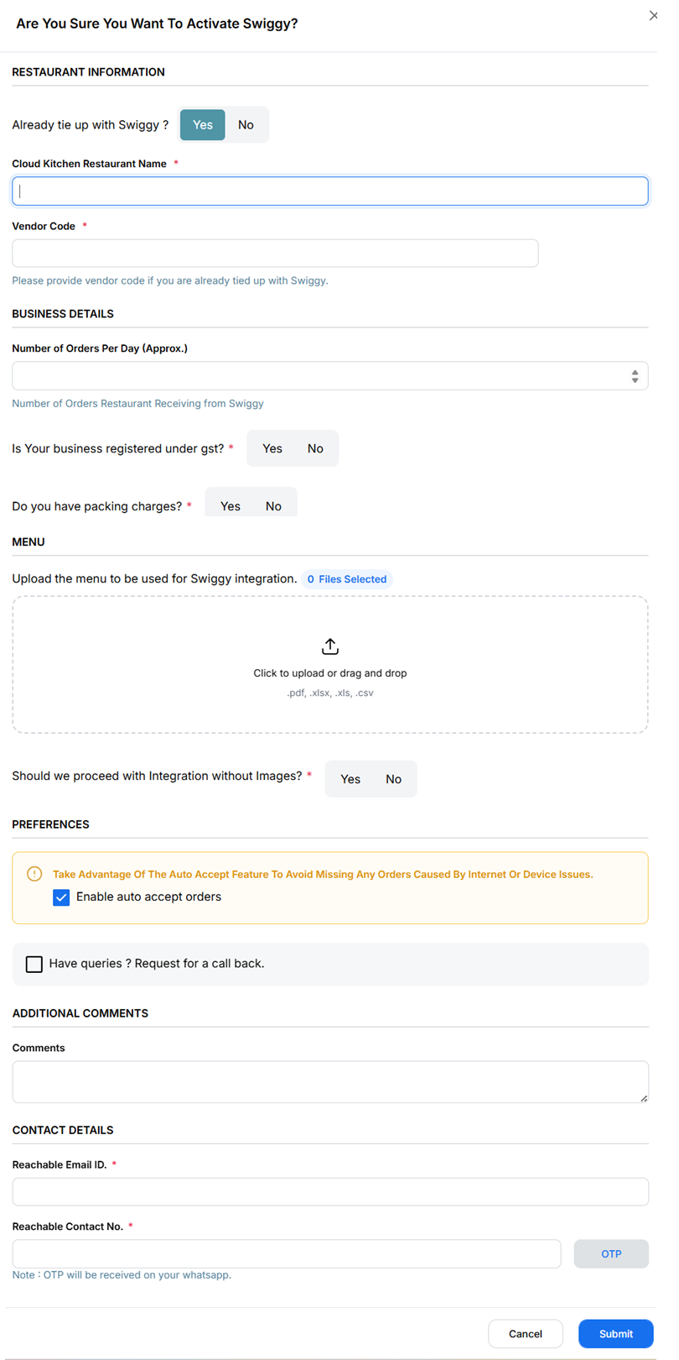
{Image Name: PetPooja Swiggy Activation Confirmation Form,
Description: This image displays the Swiggy integration form in the PetPooja dashboard.}

How to Fill the Swiggy Integration Form in Petpooja (Swiggy):
outletwise_link : https://billing.petpooja.com/market/swiggy_details/

Step 1: Already Tied Up with Swiggy ? (Swiggy):
- Select "Yes" if your restaurant is already registered with Swiggy.
- Select "No" if you are integrating with Swiggy for the first time.

Step 2: Cloud Kitchen Restaurant Name (Swiggy):
- Enter your restaurant name as listed on Swiggy.
- Ensure the spelling matches your Swiggy Profile to avoid sync issues.

Step 3: Vendor Code (Swiggy):
- If you are already tied up with Swiggy, provide your Swiggy Vendor Code.
  - You can find this code in your Swiggy Partner Dashboard or request it from Swiggy Support.

Step 4: Number of Orders Per Day (Approx.) (Swiggy) :
- Mention an approximate number of daily orders your restaurant receives from Swiggy.
  - Example: 50 orders/day, 100 orders/day, etc.
- This helps Petpooja optimize the system for your volume.

Step 5: Do You Charge GST on Your Swiggy Menu? (Swiggy) :
- Select "Yes" if GST is applicable on your menu prices.
- Select "No" if your prices are tax-inclusive or if GST does not apply.

Step 6: Do You Have Packing Charges Applied on Your Swiggy Menu? (Swiggy) :
- Select "Yes" if you charge extra for packaging.
- Select "No" if packaging is included in the menu price.

Step 7: Upload Menu for Swiggy Integration (Swiggy) :
- Click "Choose Files" to upload your menu.
- Ensure the uploaded file includes:
  - Menu items with correct names.
  - Prices as they should appear on Swiggy.
  - Taxes and additional charges (if applicable).
- Note: The attached menu will be visible on Swiggy after integration.
Step 8 : Should we proceed with Integration without Images ( Swiggy ):
- Yes, Proceed with Integration Without Images
  - Continue the integration process without adding images.
- No, Wait for Images Before Integration
  - Hold the integration process until images are available.

Step 9 : Enable Auto Accept Orders (Swiggy ) :
- Keep this checked to automatically accept orders and avoid missing any due to internet or device issues.
- If unchecked, orders may require manual approval, which could lead to delays.

Step 10: Request a Call Back (Optional)
- If you have any queries or need assistance, tick the checkbox "Have queries? Request for a call back."
- A Petpooja representative will contact you for further support.

Step 11: Comments (Optional) (Swiggy) :
- Add any additional details or special requests for the integration.
  - Example: "We operate multiple cloud kitchens" or "Urgent integration needed."

Step 12: Reachable Email ID (Swiggy) :
- Provide a working email address for official communication.
- You will receive integration updates and order-related information here.

Step 13: Reachable Contact Number (Swiggy) :

- Note : OTP will be received on your whatsapp
- Enter a valid phone number where you or your team can be contacted.

Final Step 13 : Submit the Form (Swiggy) :
- Double-check all the details and click Submit to complete your integration request.

Swiggy Integration Status Tracking in Petpooja (Swiggy ) :
outletwise_link : https://billing.petpooja.com/market/swiggy_details/
Once you have submitted your integration request, you can track the Swiggy integration process in Petpooja. The status will go through multiple steps before becoming fully operational.

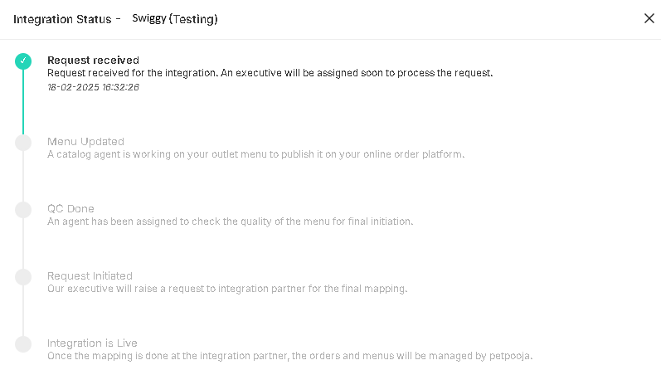
{Image Name: PetPooja Swiggy Integration Status,
Description : Here is an image of the Swiggy integration Tracking process in Petpooja.}
Integration Status Of Swiggy (Swiggy):
outletwise_link : https://billing.petpooja.com/market/swiggy_details/

Step 1: Request Received (Integration Status Of Swiggy) :
Status: Your integration request has been received.
Next Action: A Petpooja executive will be assigned to process your request.

Step 2: Menu Updated (Integration Status Of Swiggy) :
Status: A catalog agent is updating your outlet menu.
Next Action: Your menu will be published on the Swiggy platform.

Step 3:QC Done (Quality Check Completed) (Integration Status Of Swiggy) :
Status: An agent verifies the accuracy of your menu, pricing, and details.
Next Action: The team ensures that your menu meets Swiggy’s requirements.

Step 4: Request Initiated (Integration Status Of Swiggy) :
Status: A Petpooja executive sends the final integration request to Swiggy.
Next Action: Swiggy’s team will map your restaurant for order synchronization.

Step 5: Integration is Live (Integration Status Of Swiggy) :
Status: Your restaurant is now fully integrated with Swiggy.
Next Action: Orders and menus are now managed automatically through Petpooja.

